Python for Practice by using the W11_zoo.csv data

Note: upload the iPython notebook file, do not forget to add comments to your coding  
Run the codes, the outputs will be saved in iPython notebook

Classifications

* Try the following classifications: KNN, Naïve Bayes, Decision Trees, SVM, Random Forest
* Try feature selections and reductions
* Apply FS and/or FR, then repeat the algorithms above. Try to observe the change in the classification performance, e.g., accuracy

Clustering

* Ignore the label and build K-Means clustering. Try to interpret the results

Association Rules

* Use the zoo data, do not remove the labels. Perform association rules, and try to find some interesting or meaningful rules from the top rules

Finally, compare the results by using R and Python. Any interesting findings?

Classifications

K – Nearest Neighbor

* Load the dataset
* Look for missing values
* Data preprocessing - Converting categorical variables to numerical variables.
* Data preprocessing - Normalizing attributes.
* Data Split – We have used N (5) fold cross validation as data set is small
* Making models using K-Nearest neighbor algorithm for all features
* Building model after using backward elimination method
* Comparing the models built and finding the best one

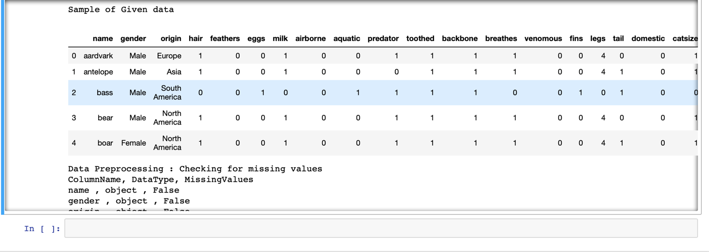

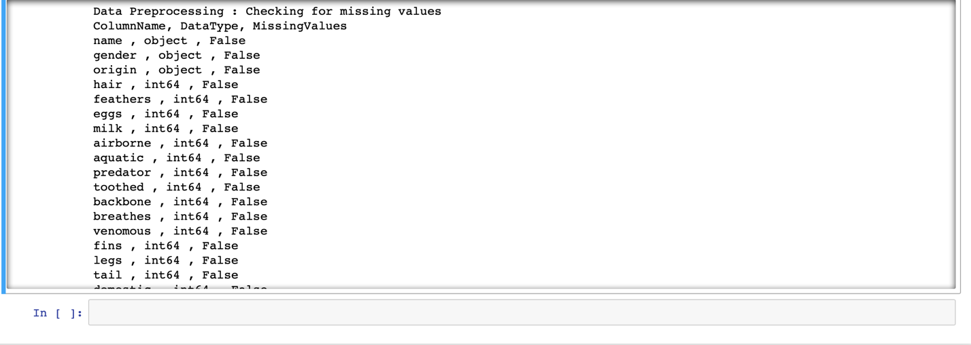

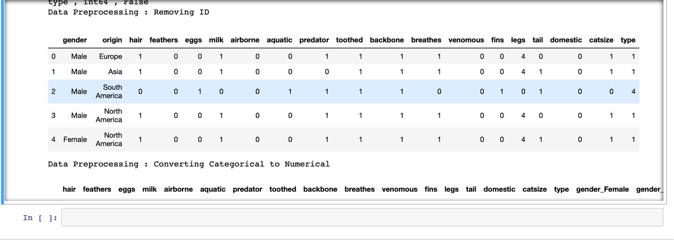

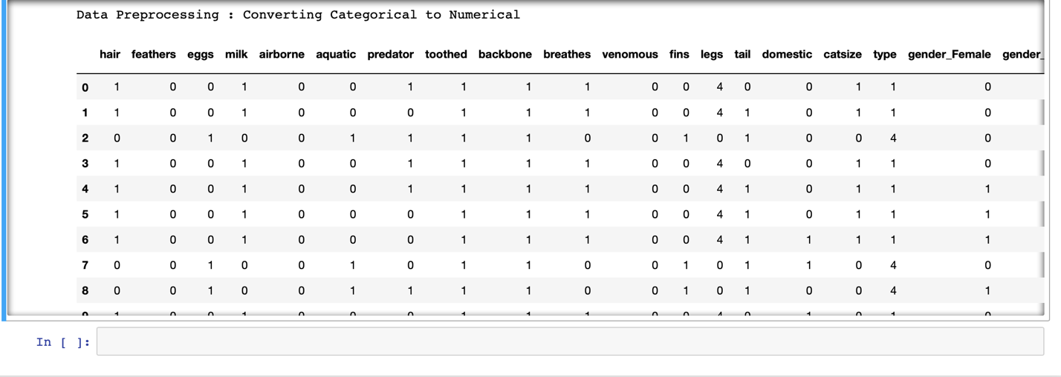

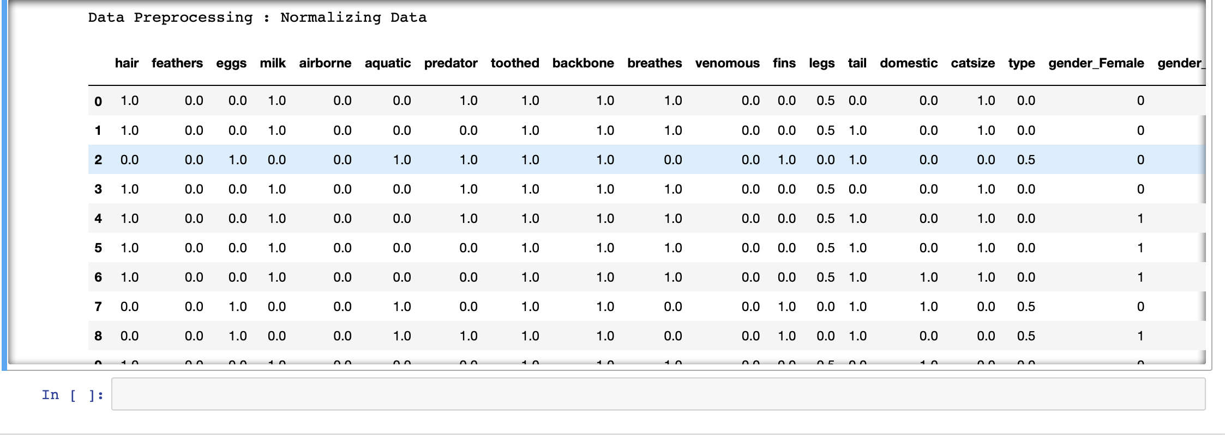

Full model

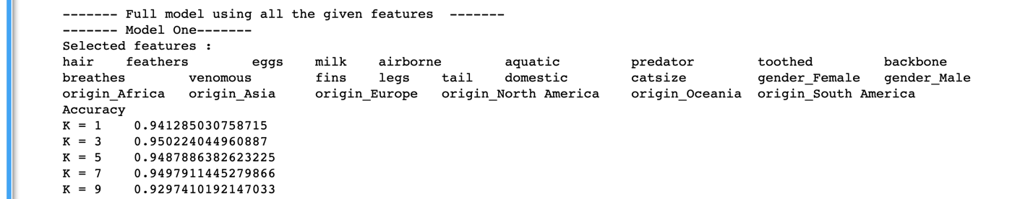

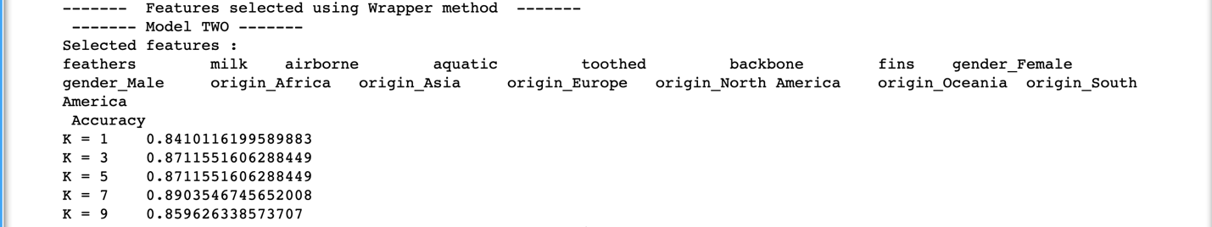

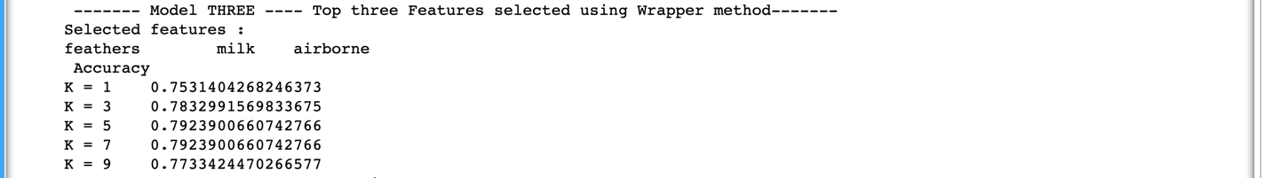

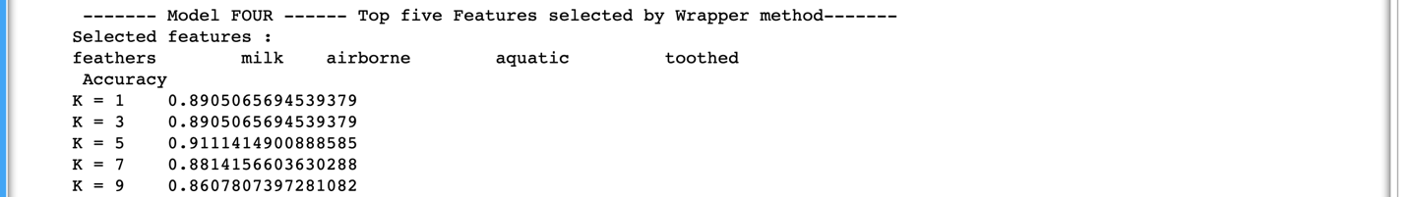

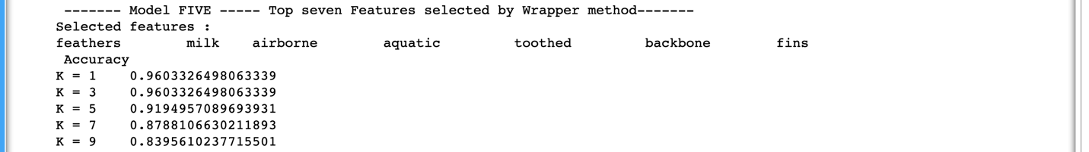

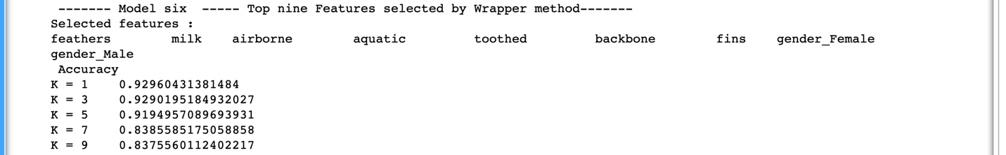

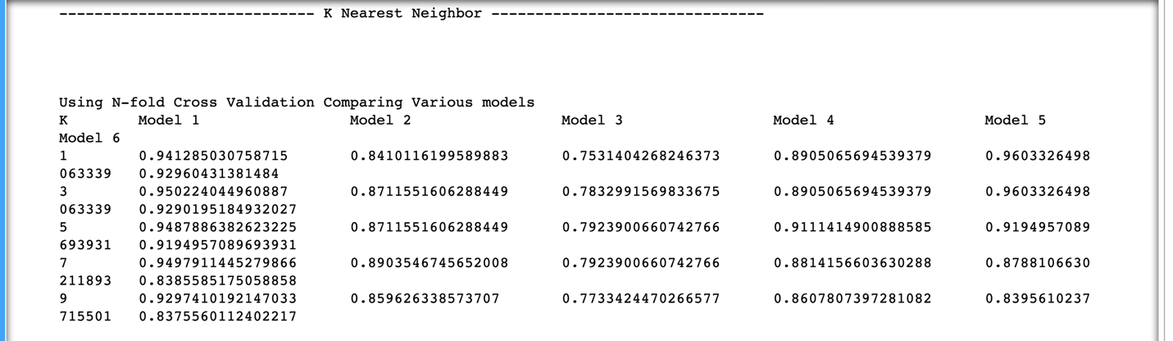

CONCLUSION

Upon comparing accuracy values, KNN performs well when we consider (Model 5) **top 7 nearest** neighbors from feature selection (Wrapper Method). The performance is best whe**n K value = 1 and 3 with an accuracy of 96.03 percent.**

NAÏVE BAYES

* Load the dataset
* Look for missing values
* Data Split – We have used N (5) fold cross validation as data set is small
* Data preprocessing - Converting Numerical variables to Categorical variables.
* Data preprocessing – Removing column - Name
* Making models using Naïve Bayes method for all features
* Building model using feature selection using top 3,5,7,10 features– **Wrapper method**
* Comparing the models built and finding the best one

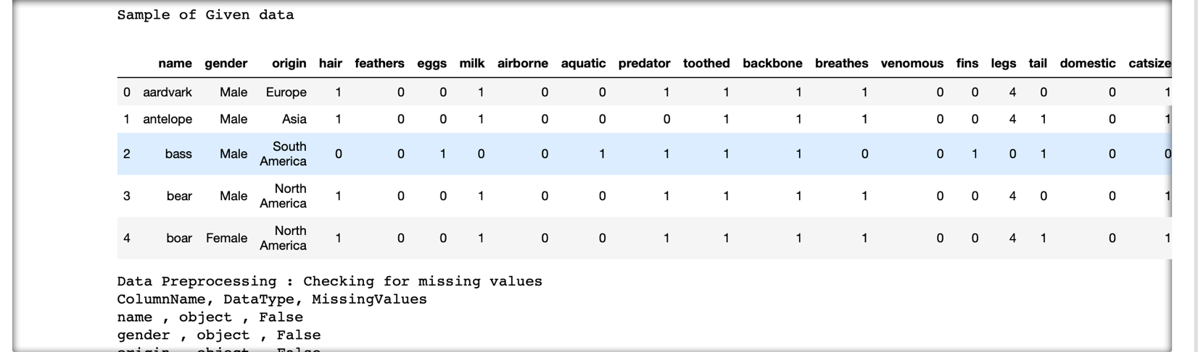

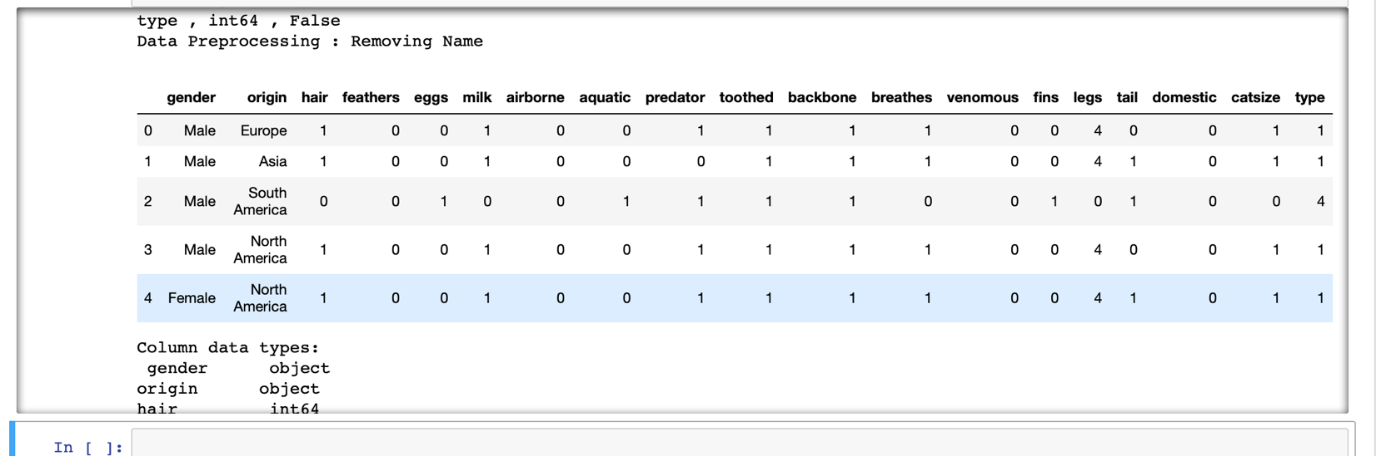

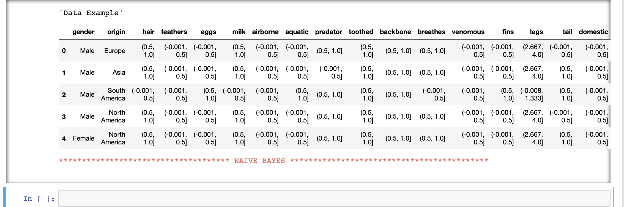

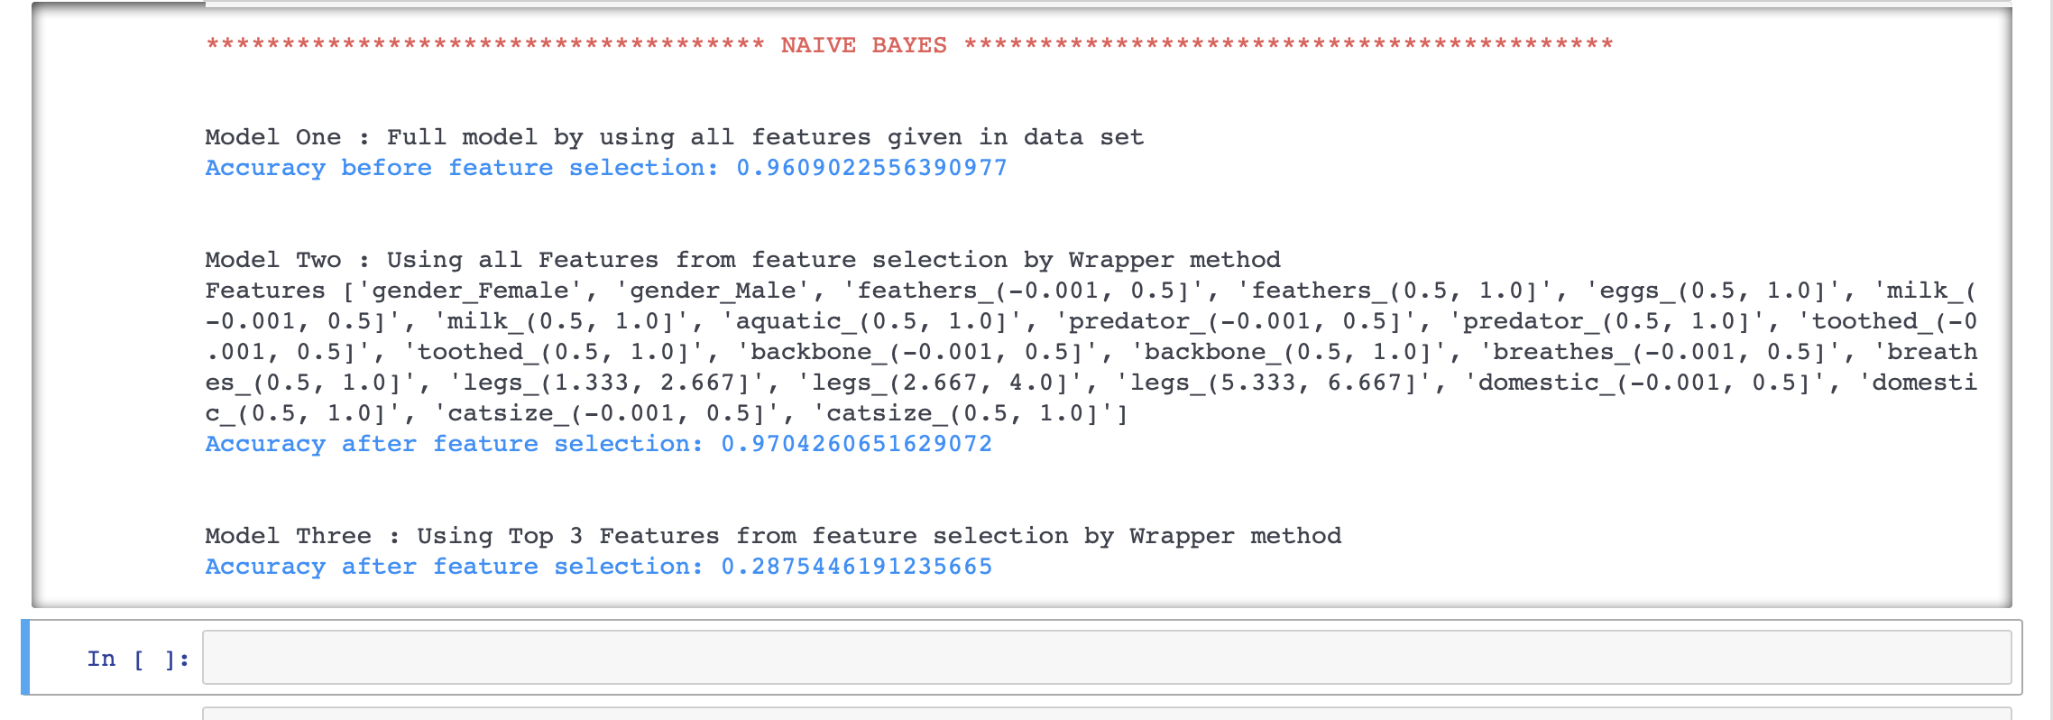

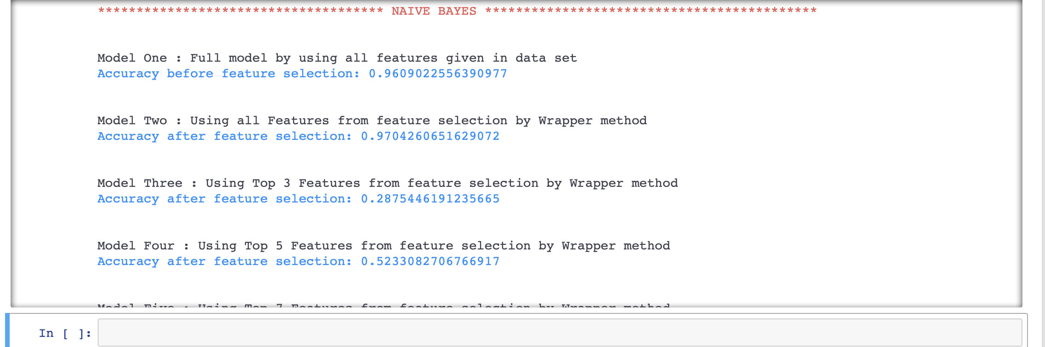

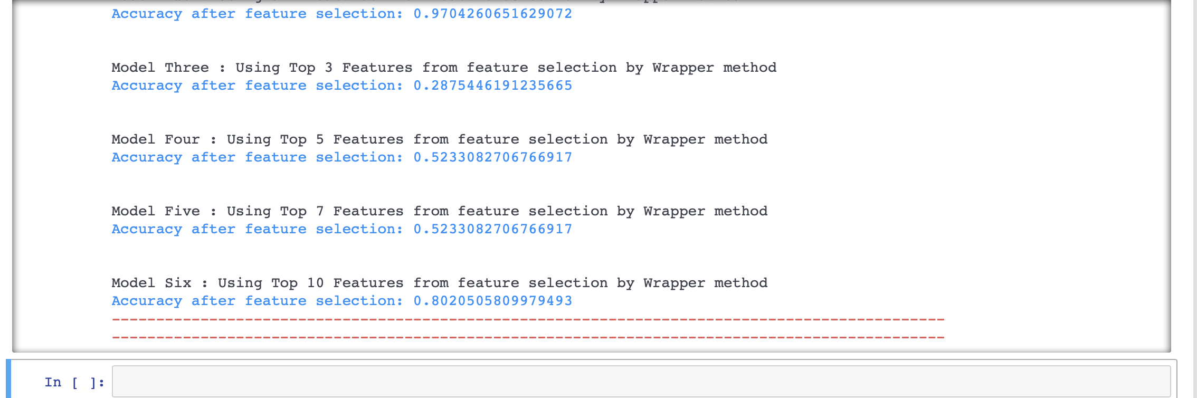

**CONCLUSION**

Upon comparing accuracy values, Naïve Bayes performs well when we consider all features selected from feature selection (Wrapper Method) with an accuracy of **97.04 percent.**

**DECISION TREE**

* Load the dataset
* Look for missing values
* Data Split – We have used N (5) fold cross validation as data set is small
* Data preprocessing - Converting Numerical variables to Categorical variables.
* Data preprocessing – Removing column - Name
* Building model using feature selection using top 3,5,2,4,5,6 features– **Wrapper method**
* Comparing the models built and finding the best one



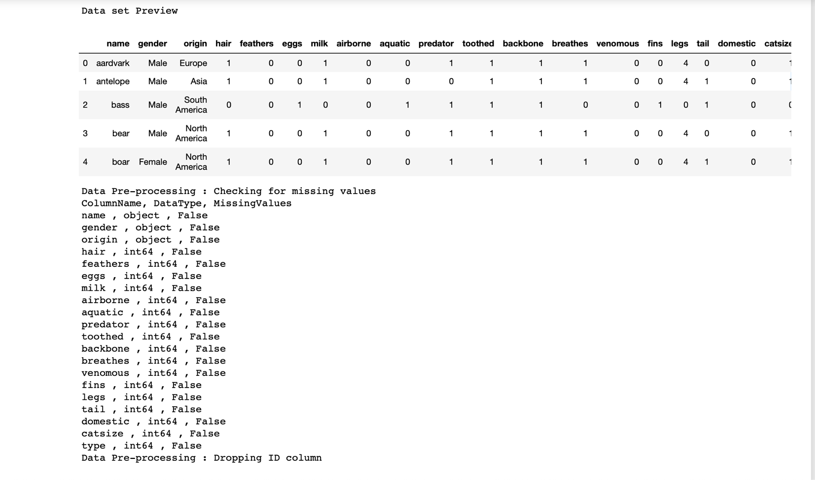

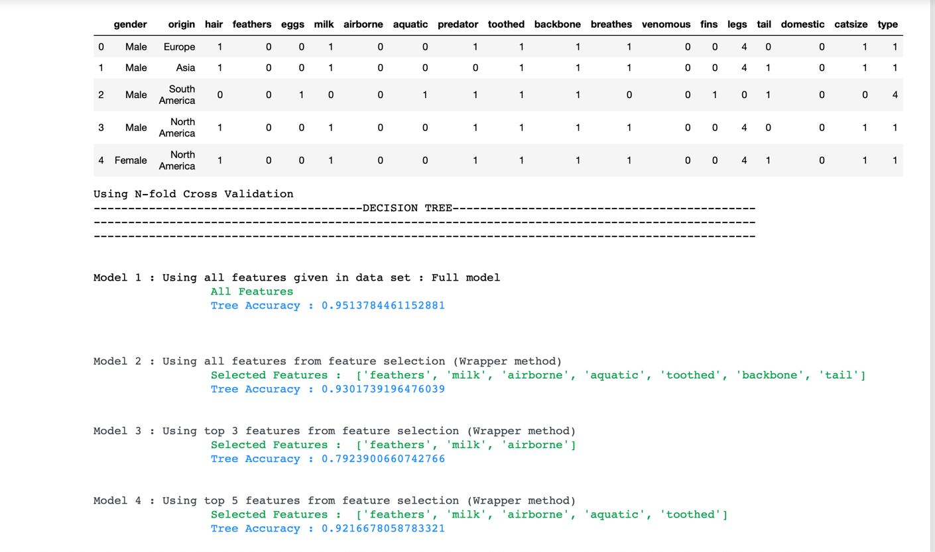

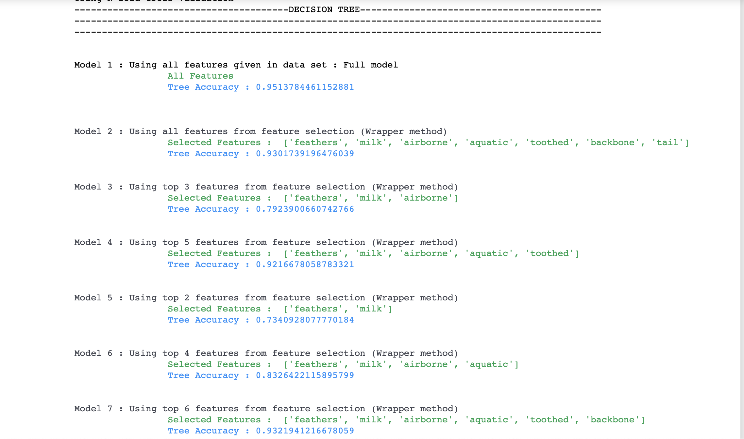

**CONCLUSION**

Upon comparing accuracies, Decision tree performs when we consider all features that is full model, which means all attributes plays important role than feature selection (Wrapper Method). The accuracy is **95.13 percent.**

**RANDOM FOREST**

* Load the dataset
* Look for missing values
* Data Split – We have used N (5) fold cross validation as data set is small
* Data preprocessing - Converting Numerical variables to Categorical variables.
* Data preprocessing – Removing column - Name
* Building model using feature selection using top 3,5,2,4 features– **Wrapper method**
* Comparing the models built and finding the best one

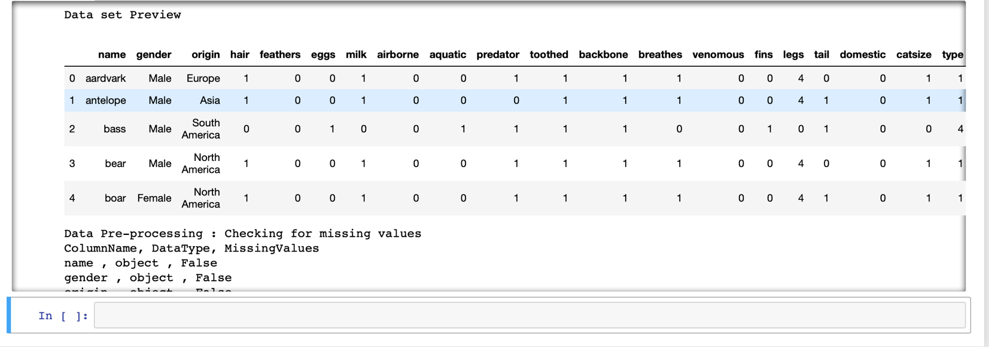

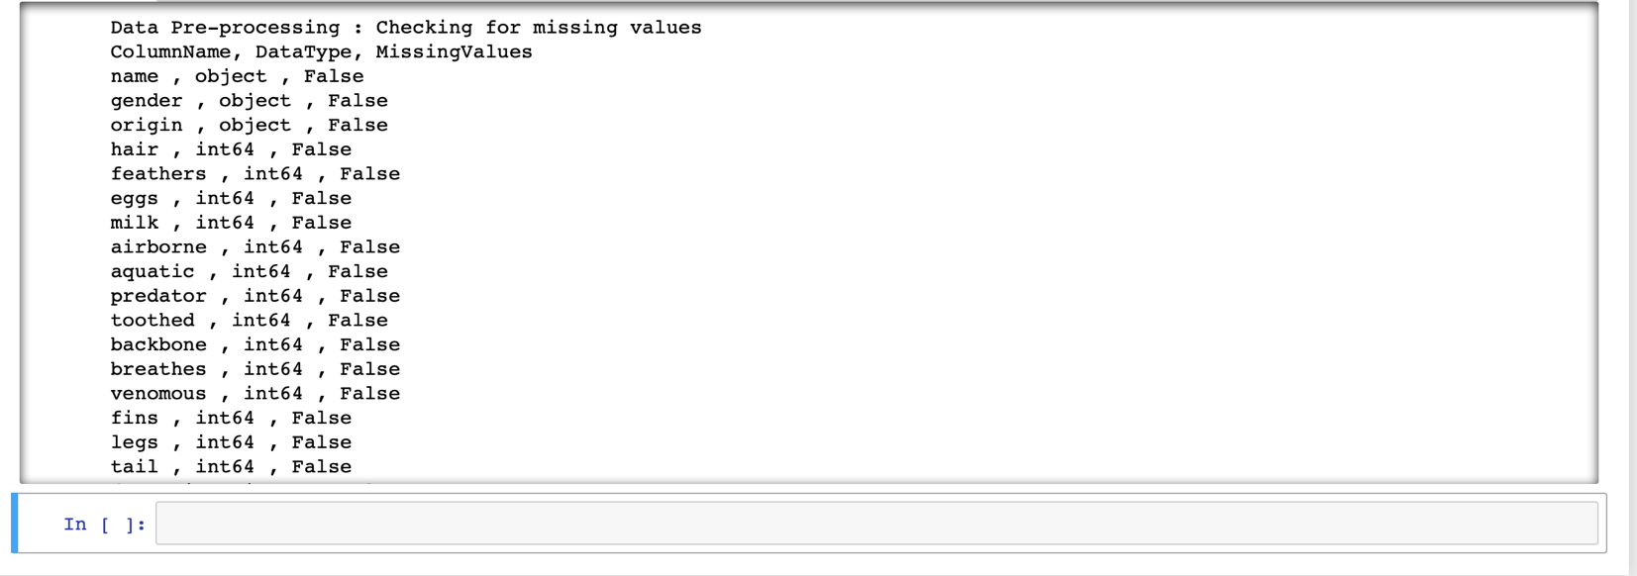

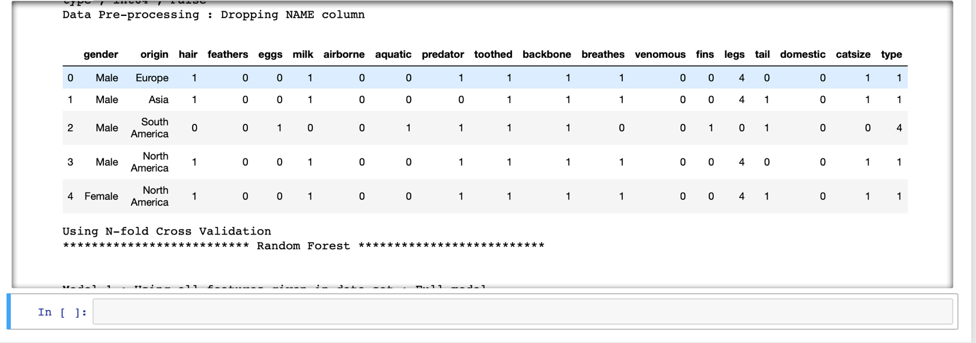

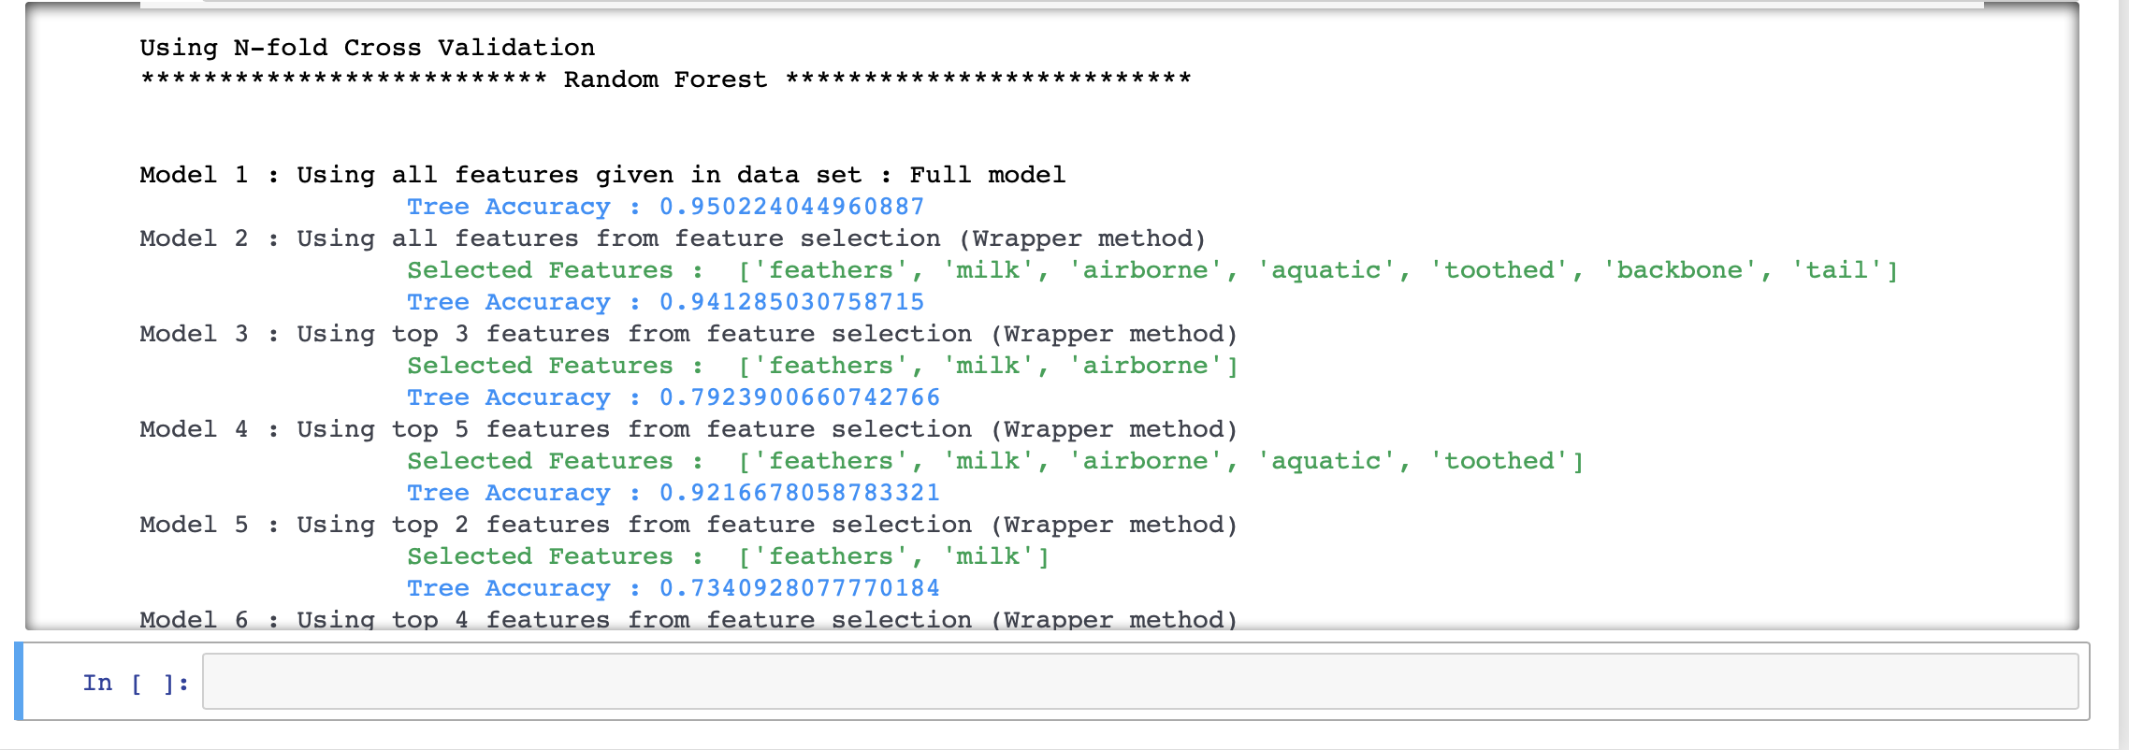

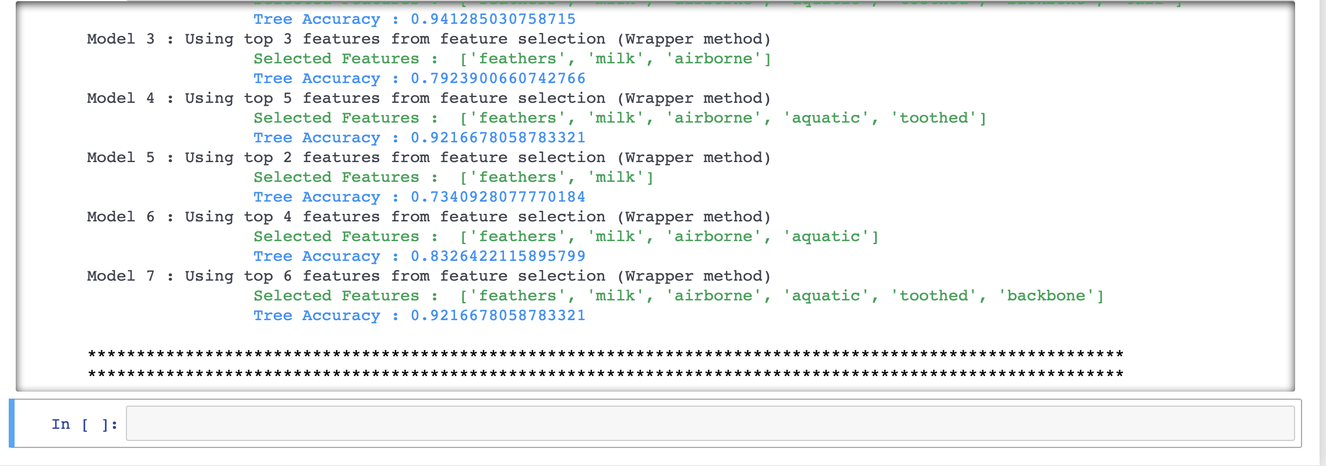

**CONCLUSION**

Upon comparing accuracies, Random forest performs when we consider all features, which means all attributes plays important role than feature selection (Wrapper Method). The **accuracy is 95.02** percent.

**SUPPORT VECTOR MACHINE**

* Load the dataset
* Look for missing values
* Data Split – We have used N (5) fold cross validation as data set is small
* Data preprocessing - Converting Numerical variables to Categorical variables.
* Data preprocessing – Removing column - Name
* Building model using feature selection using top 3,5,7,10 features– **Wrapper method**
* Comparing the models built and finding the best one

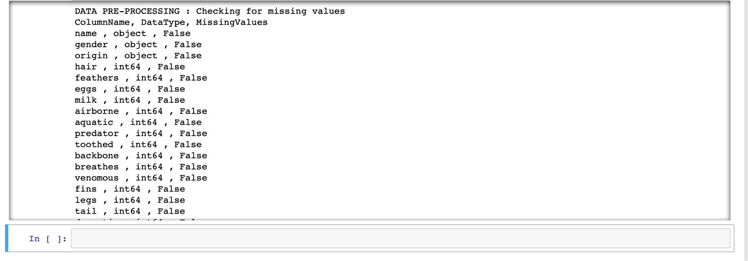

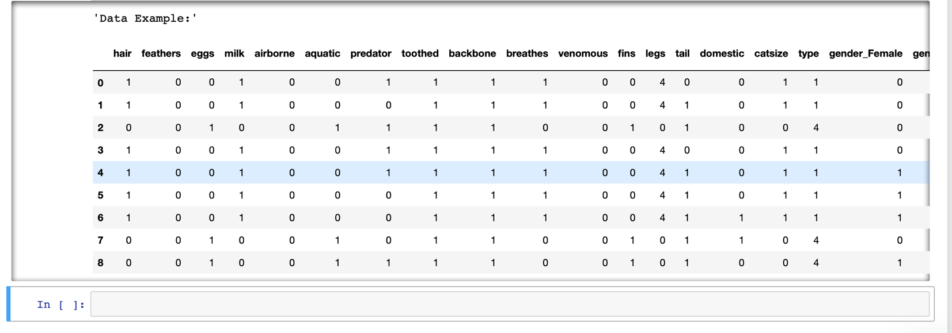

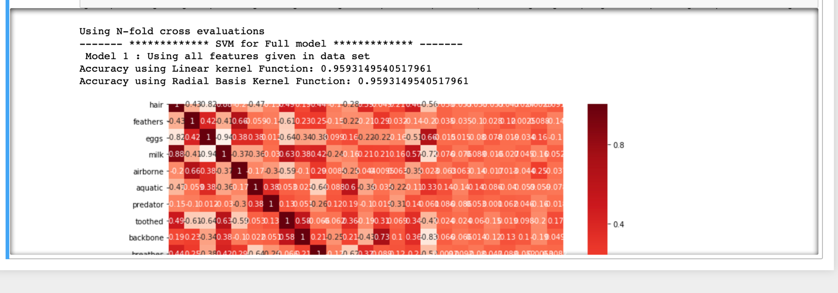

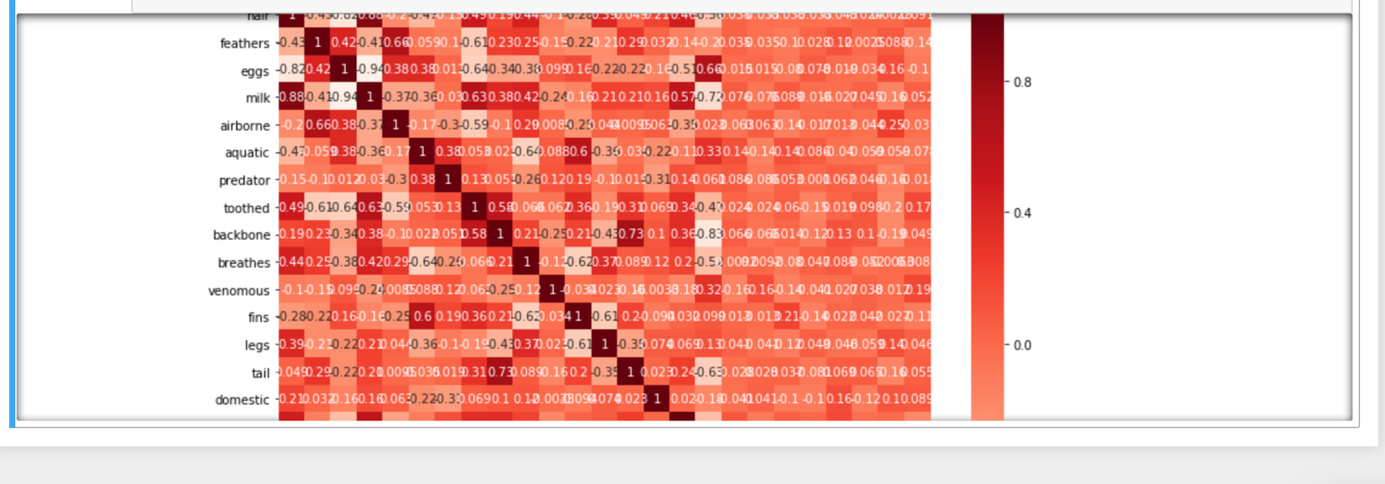

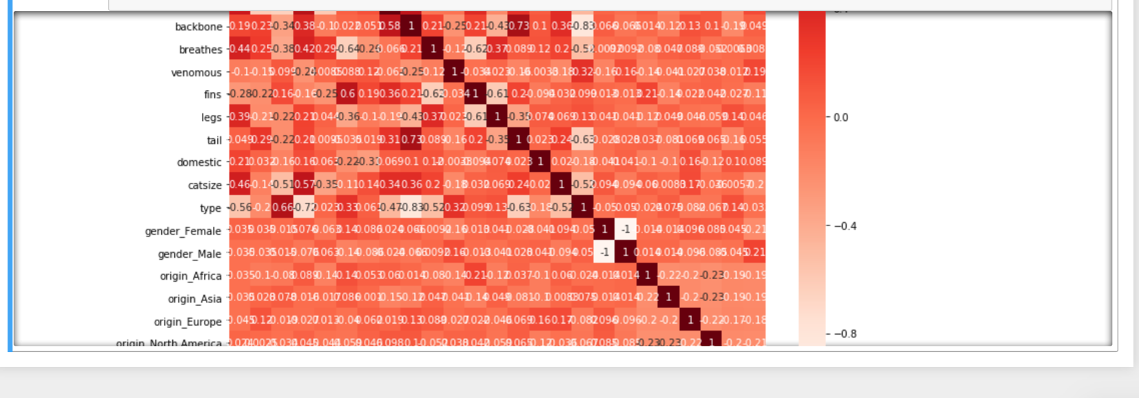

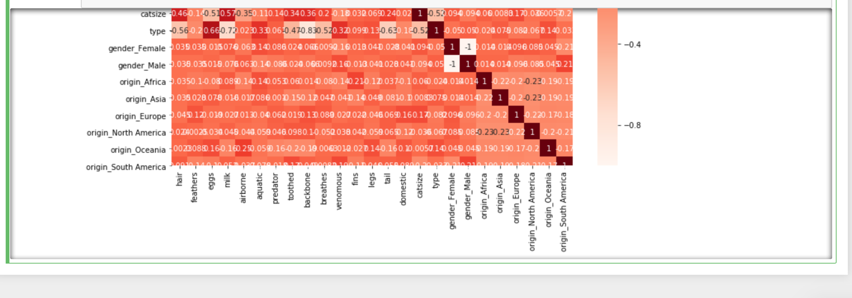

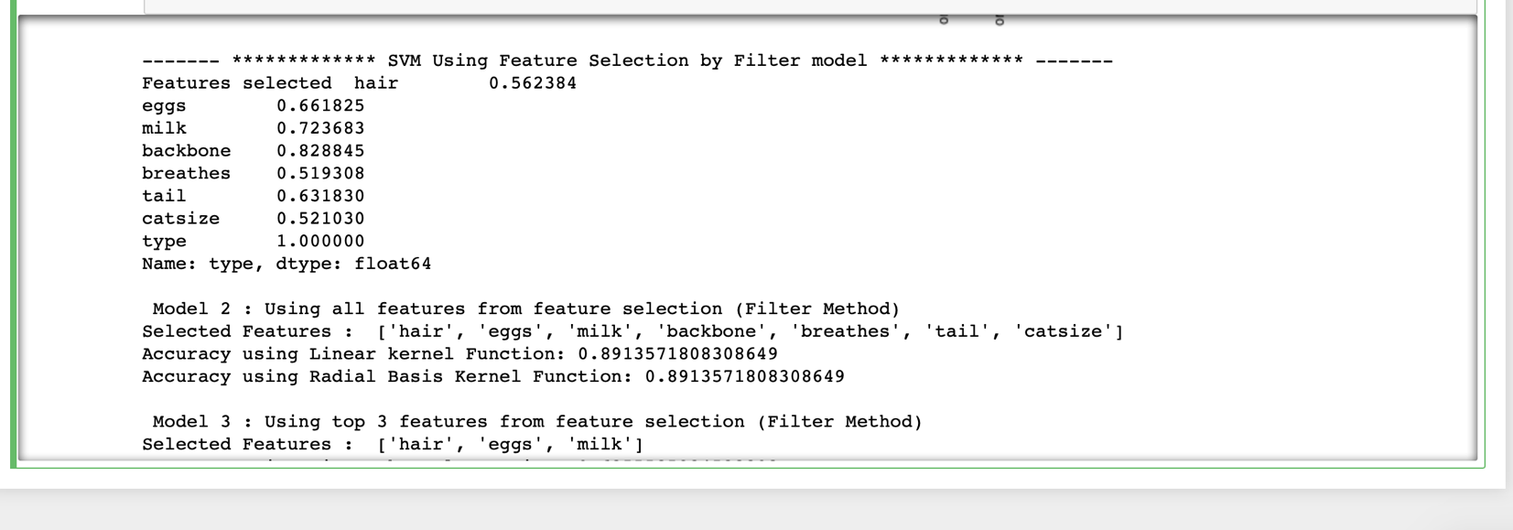

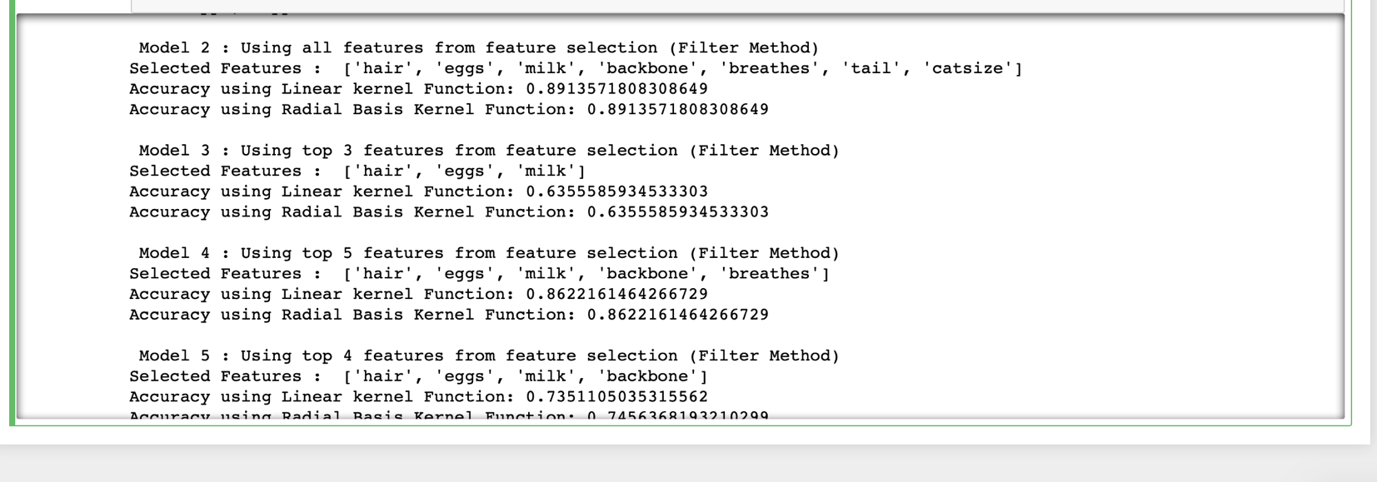

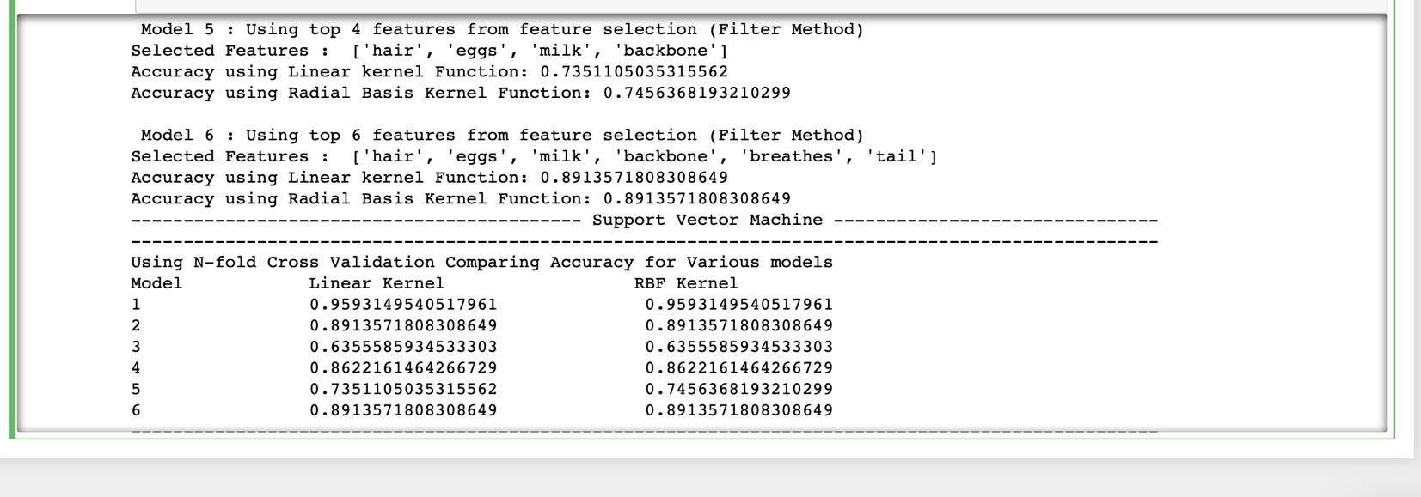

**CONCLUSION**

Upon comparing accuracies, SVM performs well when we consider all features, which means all attributes plays important role rather than using feature selection. Both Linear Kernel and RBF kernel gives same accuracy for full model.

**ASSOCIATION RULES**

▪ Load dataset into R  
▪ Look for missing values  
▪ Data preprocessing - converting numerical features to categorical

▪ Frame Association rules

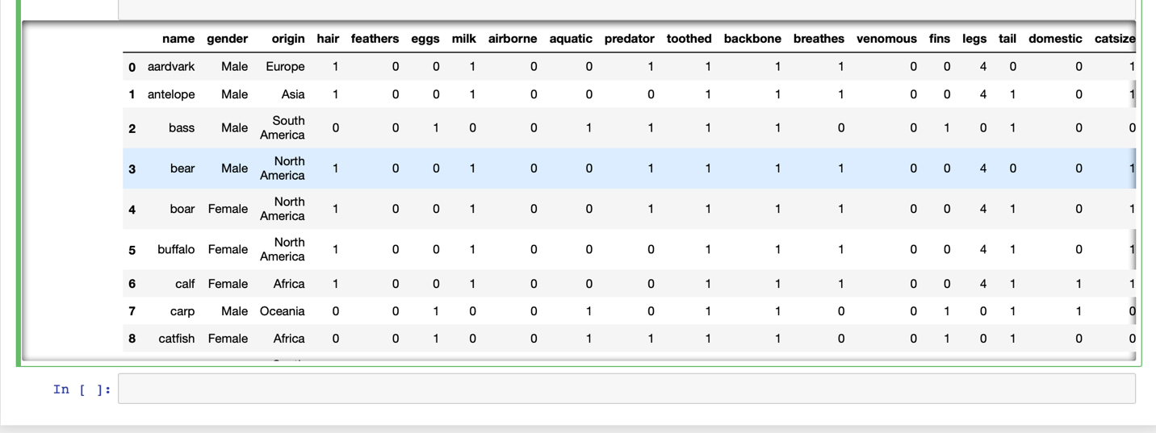

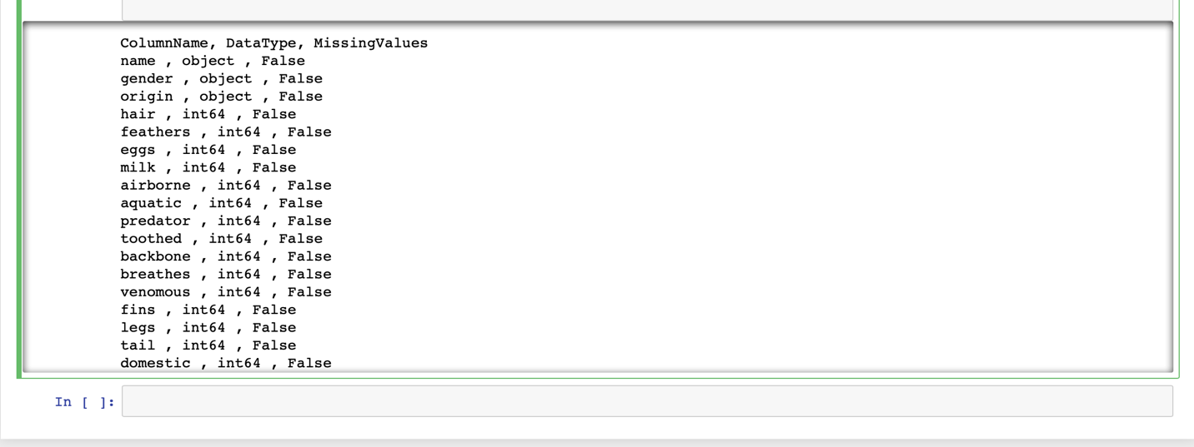

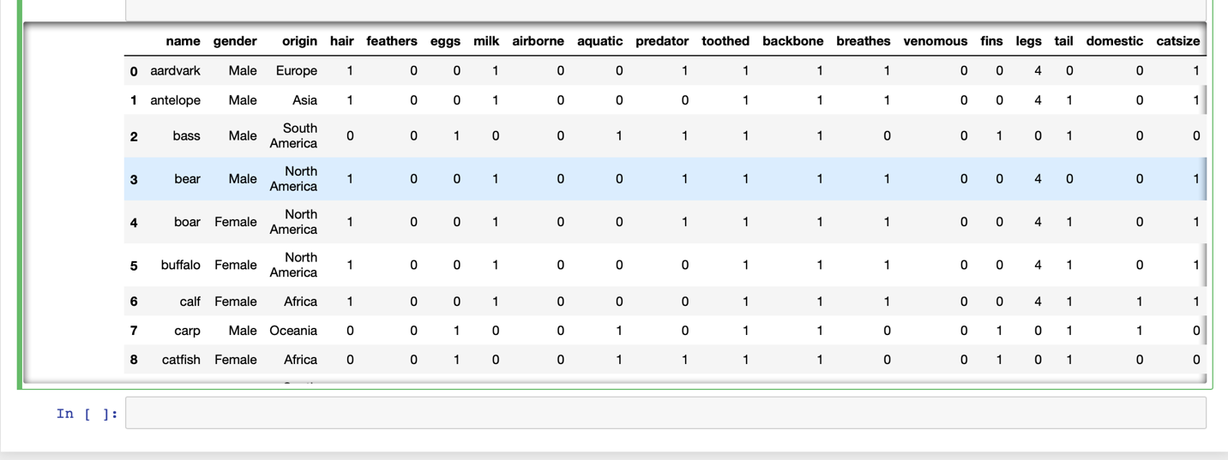

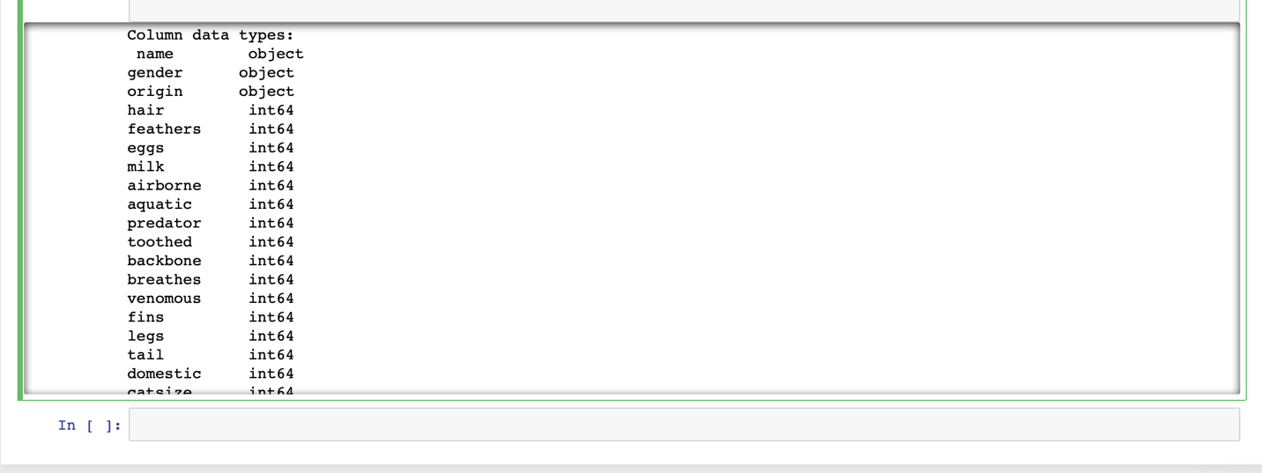

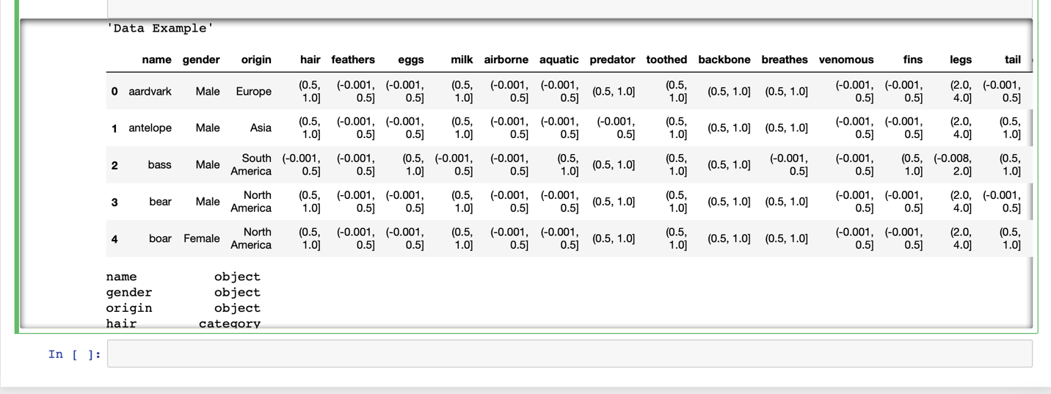

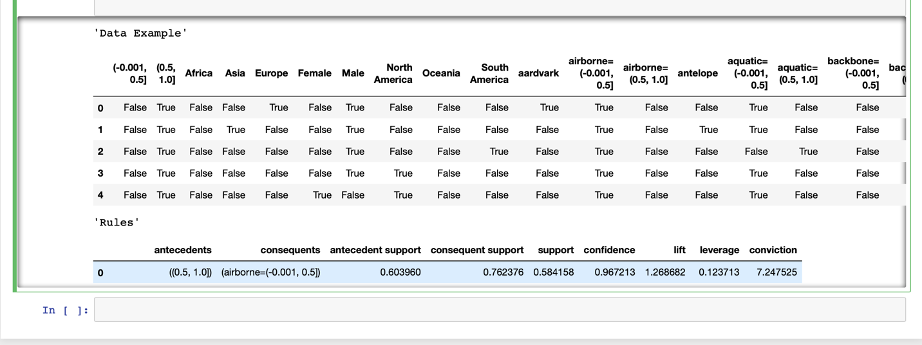

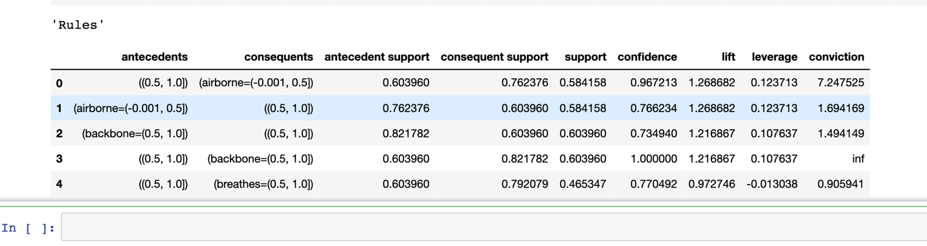

**CONCLUSION**

Above are the frequent sets for the given data which qualify the rule where support is 45 percent and confidence is 70 percent.

**CLUSTERING**

**STEPS**

* Load dataset into R
* Look for missing values
* Normalize independent attributes
* Create clusters using k-means method (no. of clusters = 4)

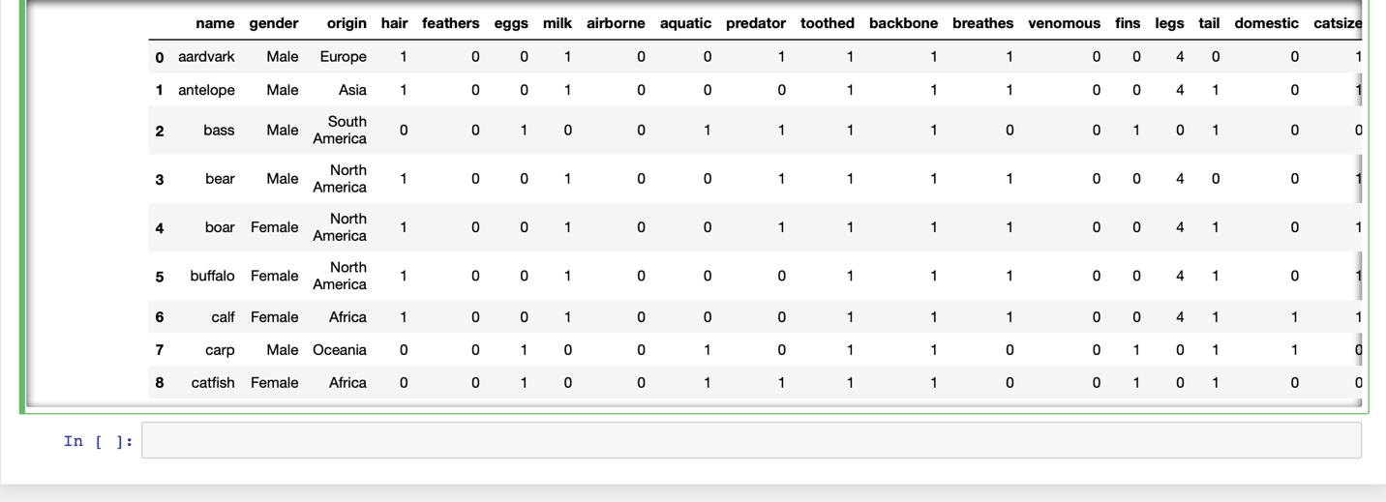

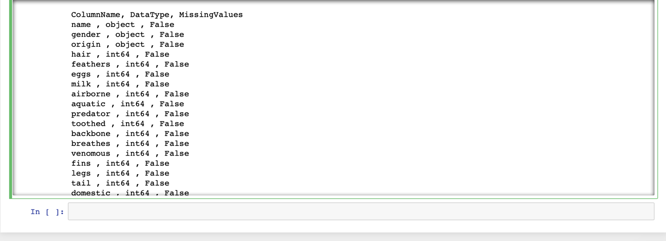

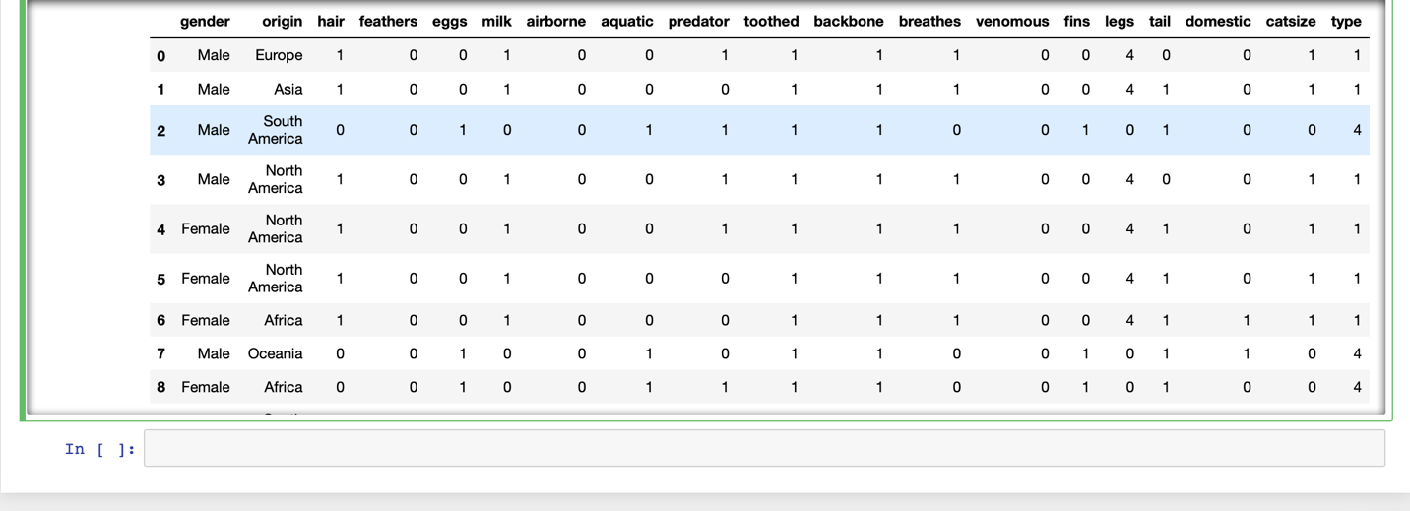



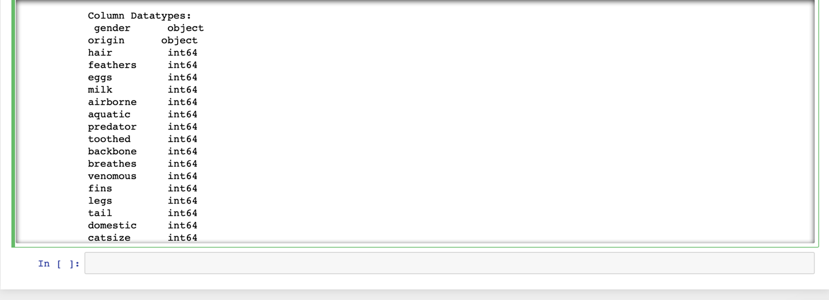

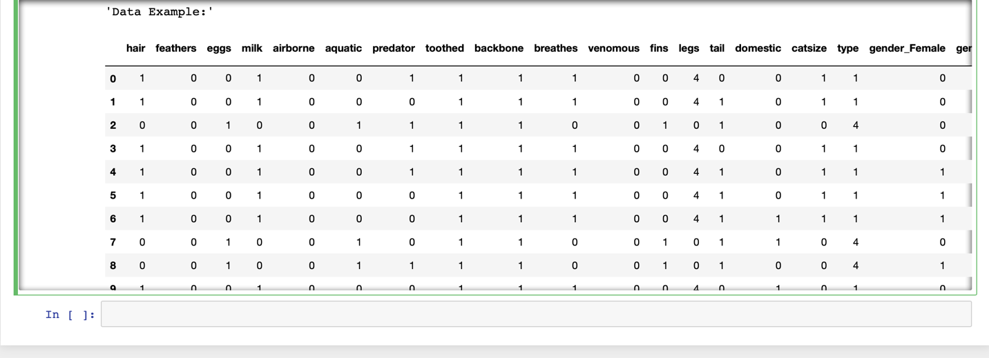

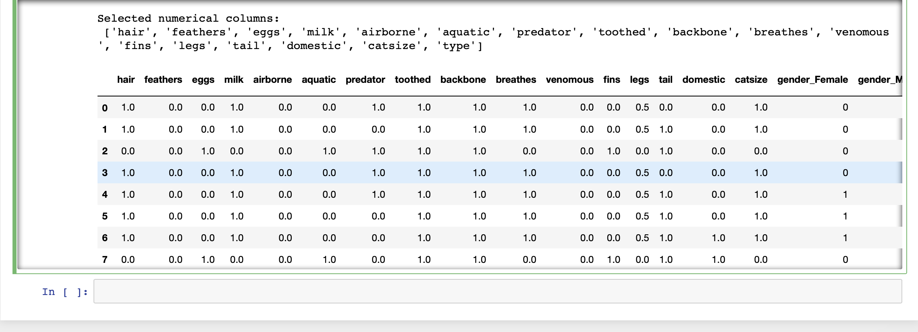

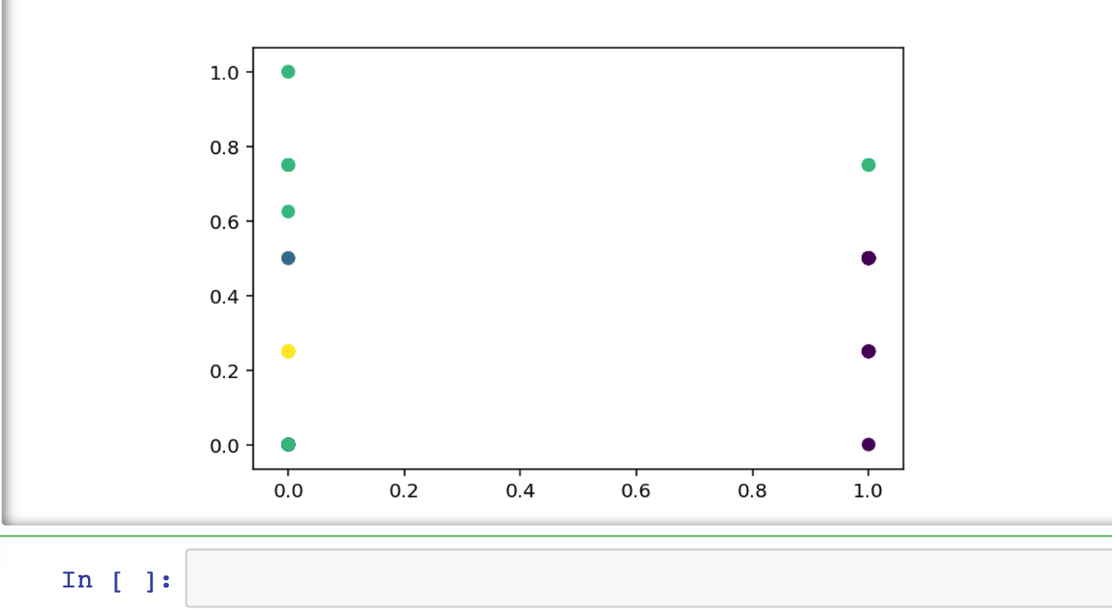

In above graph, the dots in four different colours indicates the clusters which are four in number